Testing
Steps to test:
- Ask Requirements (Hamadi) if their Implemented FunctionsTracker is up-to-date, then open Implemented Functions Tracker
- Get notified by full stack that their code is released, what is the build number
- Determine if your requirements require student and/or instructor testing
  - For student testing: use your oswego.edu email
  - For instructor testing: use your personal Gmail account
- Test the AWS server front end: https://lakerlogs.duckdns.org/
  - Open DRAFT and/or FINAL STP Test Case ReportsDRAFT STP Test Case Reports
FINAL Test Case Report
  - Open STP LogSTP Log_Bugs
  - Open QA_Templates QA_Template_STP_Bugs Report
  - Open Chrome browser on Windows OS and/or
  - Open Safari browser on Mac OS
- Fill out DRAFT Test Report during test: DRAFT STP Test Case Reports
- Record test results on STP Log Spreadsheet
- Navigate to the QA Tests folder, create or open the ST-x folder. Open or create the final test file. Create tab for which function, sub-functions you tested. If you tested more than one FR, make another tab. One tab per FR.
- Add any bugs to the Bugs/Defects tab of the Test Report.
- Add any bugs/defects to GitHub Issues
  - Title of Bug: [Bug] “STx_Defect x”
- Send system test and bug reports to full stack
- Run Automation on successful requirements and add code to: Automation Test Code
- Notify full stack, Product Owner, Requirements, and Usability that the requirements were met/unmet

Automating

Playwright Test Automation Guide
This guide explains how to record and run automated tests using Playwright.

1. Install Node.js and npm
Playwright requires Node.js to run.
- Download and install Node.js from the official website:
https://nodejs.org
- Verify the installation by opening your terminal and running:
(To open a terminal on Mac: press Command + Spacebar to open Spotlight, type "Terminal," and hit Enter.)
(Windows: search cmd in search bar)
node -v
npm -v
You should see version numbers printed for both commands.
Expected output:
mario@Marios-MacBook-Pro Playwright % node -v
v25.8.0
mario@Marios-MacBook-Pro Playwright % npm -v
11.11.0

2. Install Playwright
In your project folder, install Playwright using:
Run the following command in the terminal:
npm init playwright@latest
During setup you will see a few questions:
- Choose TypeScript when prompted.
- Accept the default location for tests (tests folder).
- Select 'No' for adding a GitHub Actions workflow.
- Accept 'Yes' to install Playwright browsers.
(Press ‘enter’ key if you get this message in the terminal: “Ok to proceed? (y)”)
Playwright will automatically download the required browsers (Chromium, Firefox, and WebKit). This may take a few minutes.

3. Record a Test Automatically
Playwright allows you to record your actions and automatically generate test code.
If you are using your personal account(not oswego.edu) you may have to do a few extra steps(in red). Otherwise you can skip this step:
STUDENT SIDE:
Step1: In your project folder, create a file savesession.js and paste the code from filecode
Step2: Run node savesession.js in your terminal. This will open LakerTracks and prompt you to sign in. Log in with your OSWEGO email, and once you have successfully signed in, return to the terminal and press Enter. Your session will only be saved after you press Enter.
INSTRUCTOR SIDE:
Step1: In your project folder, create a file savesession_instructor.js and paste the code from filecode_instructor
Step2: Run node savesession_instructor.js in your terminal. This will open LakerTracks and prompt you to sign in. Log in with your Gmail email, and once you have successfully signed in, return to the terminal and press Enter. Your session will only be saved after you press Enter.

Go to the playwright file and then -
Run the following command in the terminal / command promt:
If you completed the extra steps above(in red):
Run this command:
npx playwright codegen --load-storage=auth.json http://moxie.cs.oswego.edu:7000
EX:
Student:
npx playwright codegen --load-storage=auth.json https://lakertracks.duckdns.org/
Instructor:
npx playwright codegen --load-storage=auth_instructor.json https://lakertracks.duckdns.org/
If you skipped the extra step(s), run the following
npx playwright codegen http://moxie.cs.oswego.edu:7000
npx playwright codegen https://lakertracks.duckdns.org/
This will open a browser window and a Playwright inspector.
Now perform the actions you want to test in the browser (clicks, typing, navigation).
Playwright will automatically record each step and generate the corresponding test code.
Output:
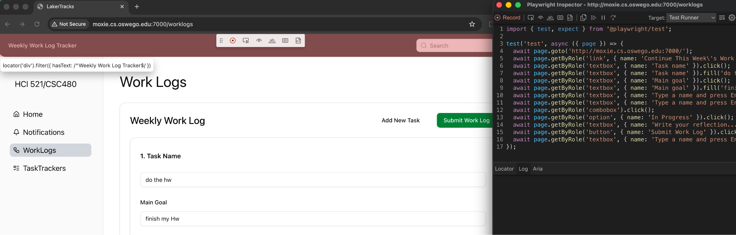

4. Create a Test File
- Copy the generated code from the playwright recorder.
- Paste the copied code in a new text file (use any text editor in your device)
- Save the text file in this format: filename.spec.ts
Example:
test.spec.ts
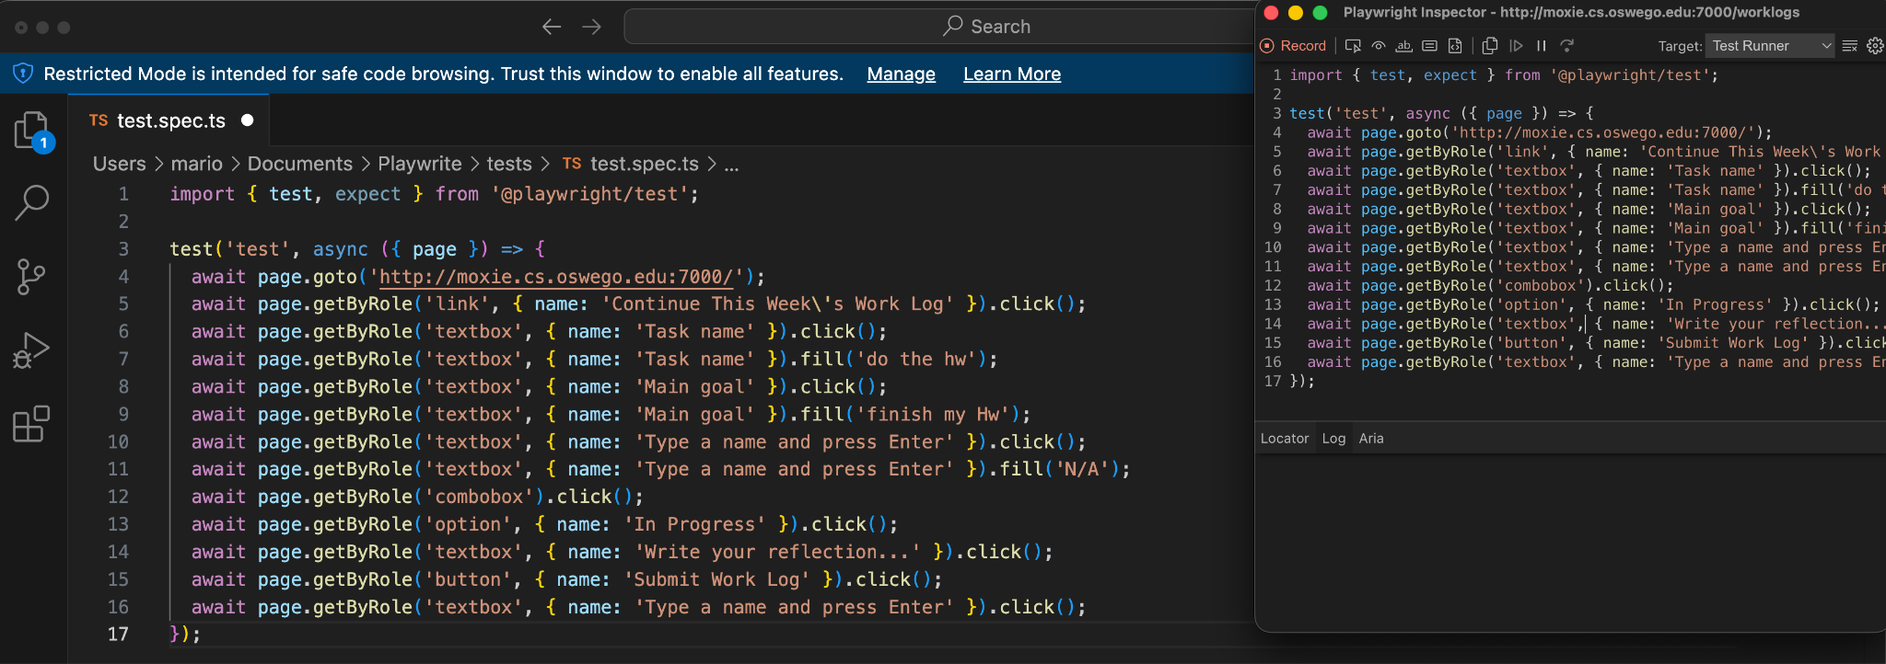

5. Run the Test (2FA get around)

How to set up test environment:

Step one:

- Make a folder and name it something

-- example (playwright-tests) can be anywhere on your device.

-- For this I just made it on my desktop.

- Inside the folder make another folder name it tests

Step two:

- Open command prompt

- use the cd command to enter the directory of your folder

-- example (cd C:\Users\username\OneDrive\Desktop\playwright-project)

Step three: *important step*

- Run these commands in your project directory

-- npm init -y

-- npm install -D

-- npx playwright install

// These are to verify your playwright install and version in your folder

Step 4:

- Open text editor paste the code below

- Save the file under the name saveAuth.js and put it in your project folder

const { chromium } = require('@playwright/test');

(async () => {

const browser = await chromium.launch({ headless: false }); // visible browser

const context = await browser.newContext();

const page = await context.newPage();

// Go to your site

await page.goto('http://moxie.cs.oswego.edu:7000/signup');

console.log('Log in manually, then press ENTER here in the terminal...');

// Wait for you to finish login + 2FA

process.stdin.once('data', async () => {

await context.storageState({ path: 'auth.json' });

console.log('Auth state saved to auth.json');

await browser.close();

process.exit();

});

})();

Step 5:

- In command prompt still in your project directory

-- run this command:

node saveAuth.js

-- Log into the website using your school credentials and 2 factor authentication
- - if it says could log you in because it is not secure follow these additional steps otherwise continue:
– click in the 3 dots in the top right of your browser
– select settings
– go to privacy settings
– site settings
– click javascript
– click add under sites to allow
– add the moxie server click enter
– click on the little arrow next to the web link
– scroll down and click the dropdown under insecure content
– click allow then back on the moxie server reload
– continue with log in
(this should all be done inside the node saveAuth.js command)

-- once logged in alt tab back to command prompt and click enter

// this has now saved a state of you being logged into the website

Step 6:

- In text editor paste in the playwright code you need to test

- Remove the first part of the code that has the log in code

- paste this where the old code was

import { test, expect } from '@playwright/test';
// This loads your save state

test.use({ storageState: 'auth.json' });

//name the test below the name of the test

test('test4.1', async ({ page }) => {

await page.goto('http://moxie.cs.oswego.edu:7000/');

// This is the actual test code for 4.1 below you don't need to paste this

await page.getByRole('link', { name: 'Continue This Week\'s Work Log' }).click();

await page.getByRole('button', { name: 'Submit Work Log' }).click();

await expect(page.getByText('Task name is required')).toBeVisible();

await expect(page.getByText('Main goal is required')).toBeVisible();

await expect(page.getByText('Deadline is required')).toBeVisible();

await expect(page.getByText('Select completion status')).toBeVisible();

await expect(page.getByText('Reflection is required')).toBeVisible();

});

Step 7:

- Save the code to your tests folder under the name of the test followed by .spec.ts

-- example (FR4-1.spec.ts)

- Now in your project directory in command prompt

-- run (npx playwrite test) to test all tests within the tests folder

-- you can add --headed to the end of that command to see the test being run

-- if you want to run a specific test use cd to enter your tests folder and run (npx playwrite test FR4-1.spec.ts)

-- you may need to rerun the node saveAuth.js command before running your tests

6. Run the Test with ui mode
Make sure you are in the correct project directory, then run the test using:
Run the following command in the terminal:
npx playwright filename --ui

(From our above example, filename = test (DO NOT INCLUDE .spec.ts HERE ))
The Playwright UI will open and allow you to run, debug, and observe your test execution.
